**Connecting to Apache Drill to query different datasets.**

Open the browser on hortonworks sandbox and visit the URL 10.80.2.4:8047. It displays various tabs as shown.

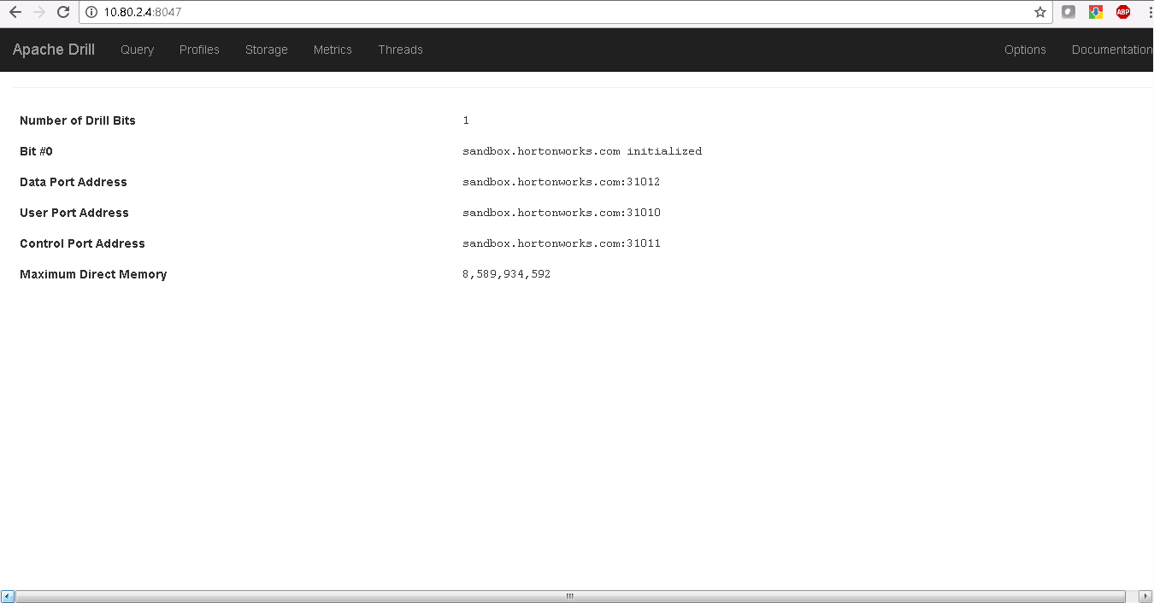

To see all the connections, click on storage plugin.

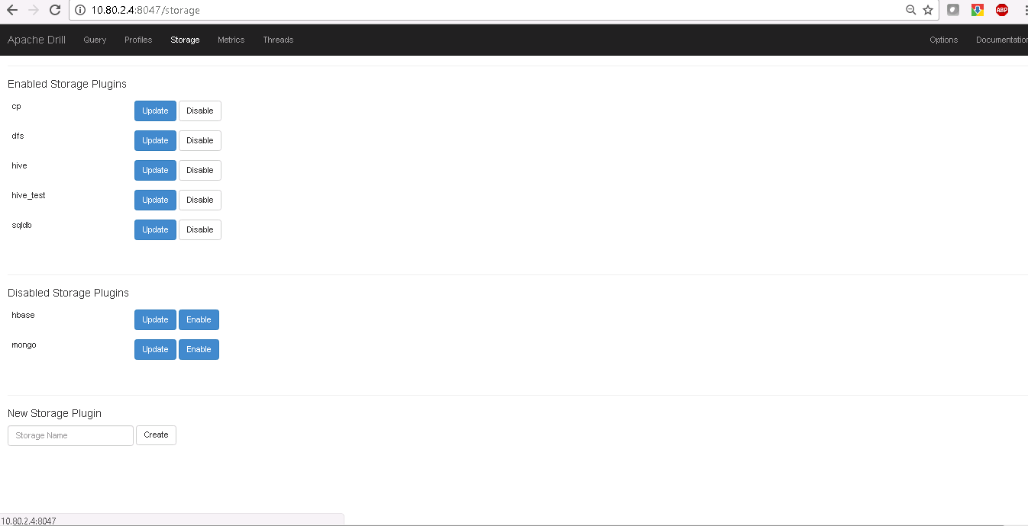

Click on update button to see the connection details.

Eg:

1. hive_test storage plugin shows the connection details to hive on Hadoop
2. sqldb storage plugin shows the connection details for connectivity to MSSQL server

To create a new connection, give a name for storage plugin in the New Storage Plugin tab below, click on create, configure the connection and click on Create button.

Provide below details for configuration:

{

“type”:”jdbc”,

“driver”: “<driver-path>”,

“url”: ”<databaseurl>”,

“username”: <username>,

“password”: <password>,

“enabled”:true

}

Once the storage plugin is created, click on Query to write a select statement and execute the same

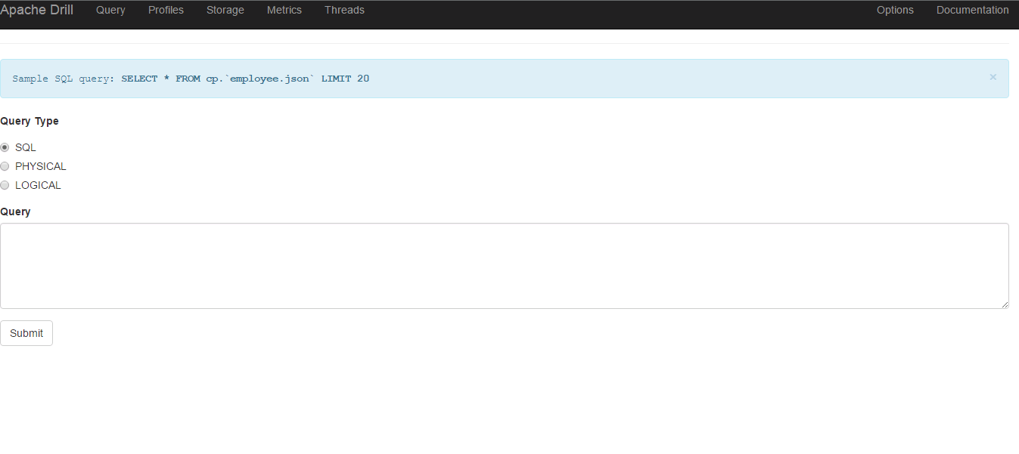

To select the data from Hive external table for a partition, write the query in the text provided and click submit

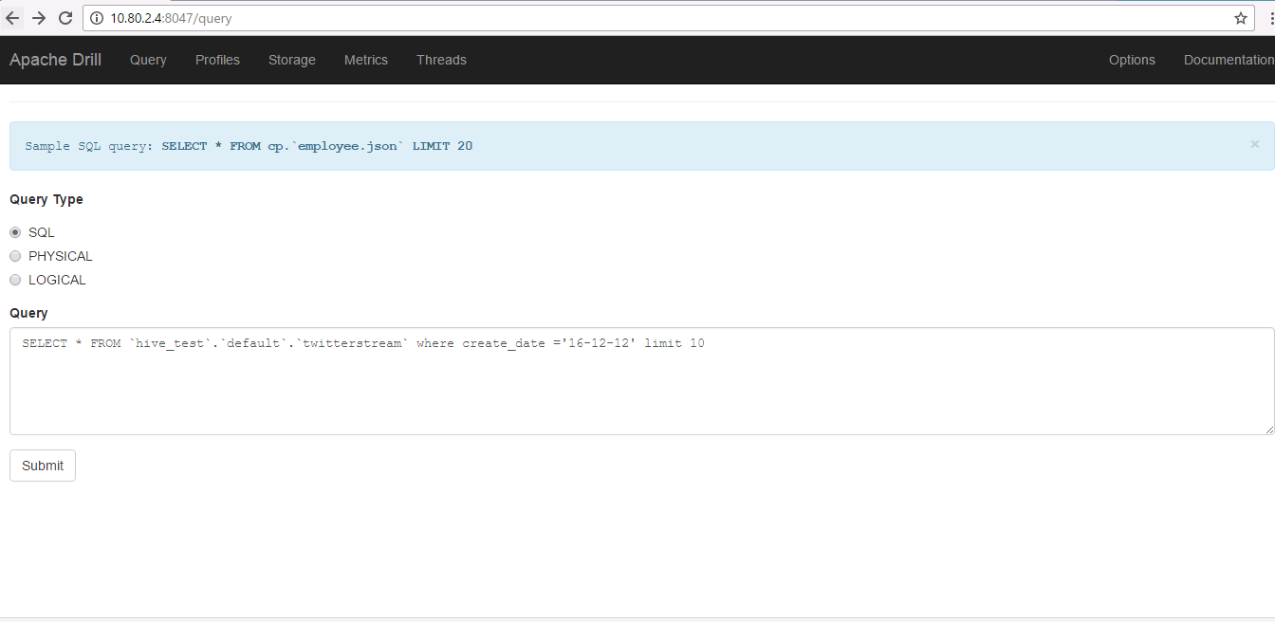

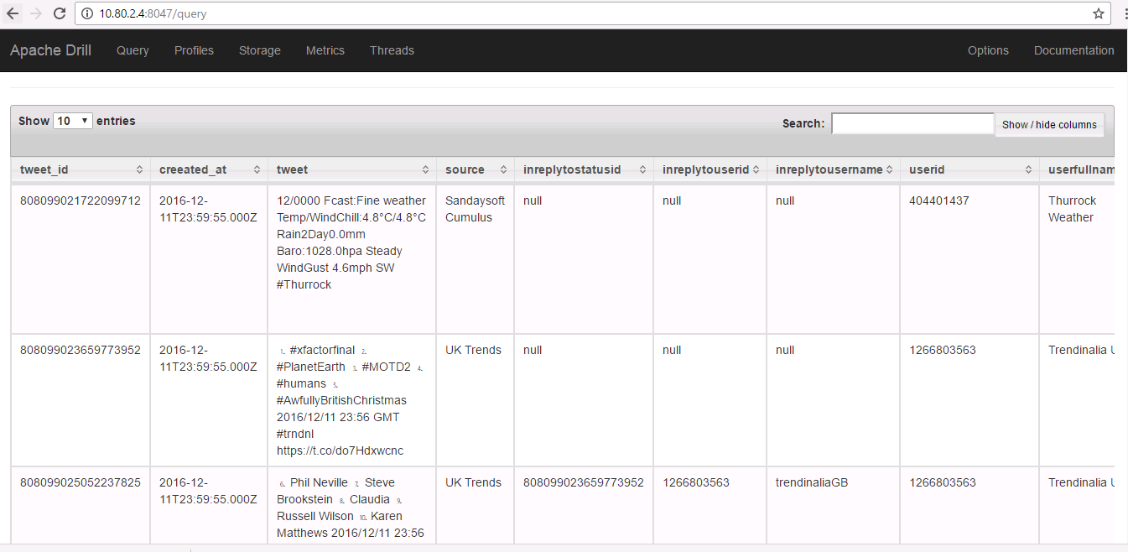

To get the data from an existing table in MSSQL , use the below query

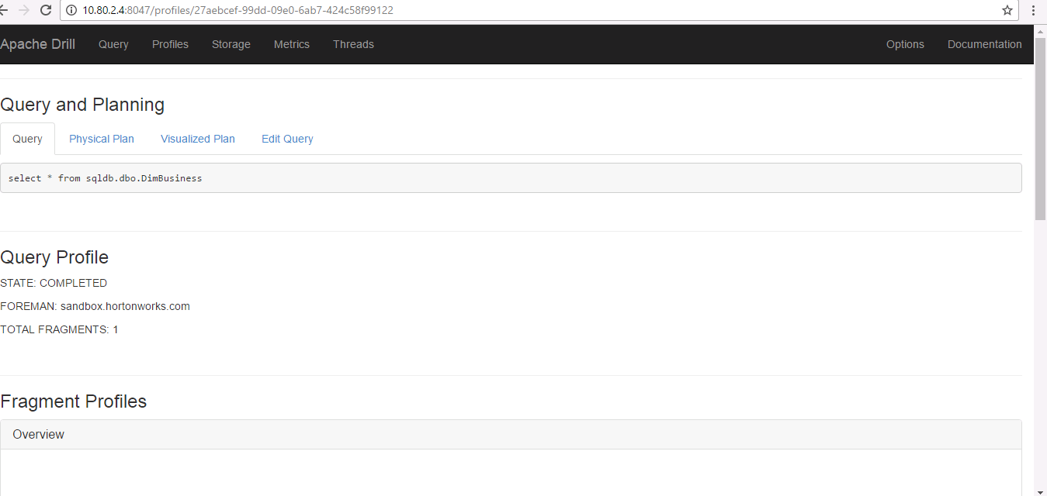

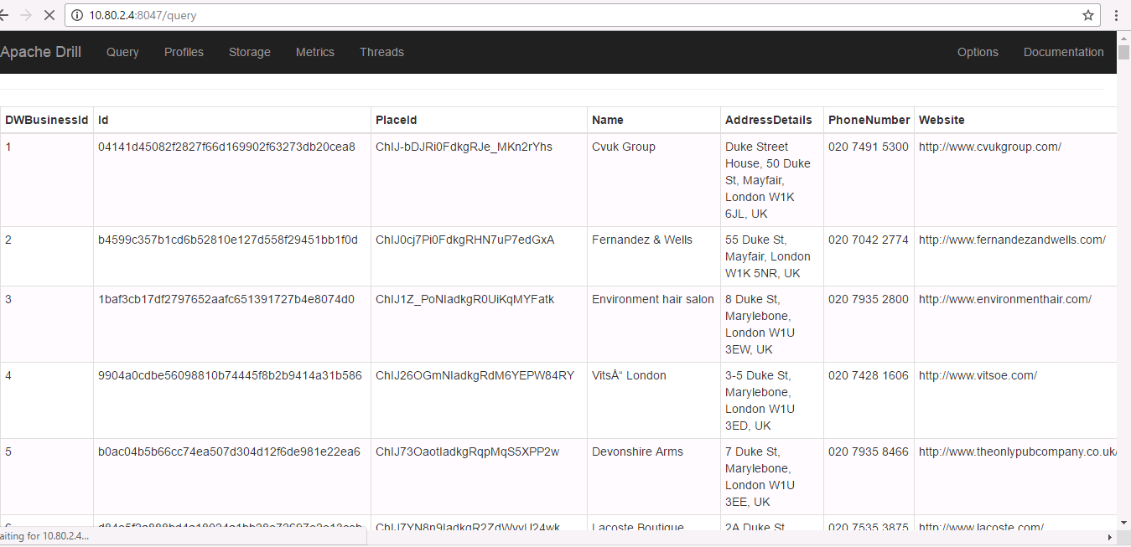

Apache Drill provides Rest API calls.

There are different HTTP methods for all the functions that appear in the Drill web console (i.e for Queries, storage, Profiles)

Query

Using the query method, you can programmatically run queries.

POST /query.json

Submit a query and return results.

Parameters

queryType--SQL, PHYSICAL, or LOGICAL are valid types. Use only "SQL". Other types are for internal use only.

query--A SQL query that runs in Drill.

Request Body

{

“queryType”:”SQL”,

“query”: “<Drill Query>”

}